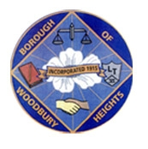 ANNOUNCEMENT!!!!!!! 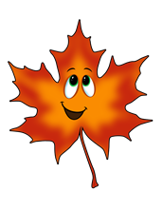
BOROUGH OF WOODBURY HEIGHTS FALL 2023 LEAF COLLECTION
CONTINUED SCHEDULE FOR COLLECTION
- Week of December 11, 2023 West Side of Railroad Tracks (Tracks to 45)
  - (Poplar/Maple area, Elm Ave, St. Margarets section, Summit area)
- Week of December 18, 2023 East Side of Railroad Tracks (Academy and Lake Sections)

FALL 2023 LEAF COLLECTION FINAL PICKUP WILL BEGIN AFTER CHRISTMAS (WEEK OF 12/25). PUBLIC WORKS WILL MAKE ONE MORE ENTIRE COLLECTION OF TOWN (ALL AREAS).

Curbside brush collection is being done biweekly for Public Works to focus on leaf collection. Next 3 pickup dates are as follows;
- Monday 12/11/2023
- Wednesday 12/27/2023 (due to holiday)
- Monday 1/8/2023

Ryan Wells
Public Works Director, Woodbury Heights
856-848-2832 ext 35
ppwm@bwhnj.com

