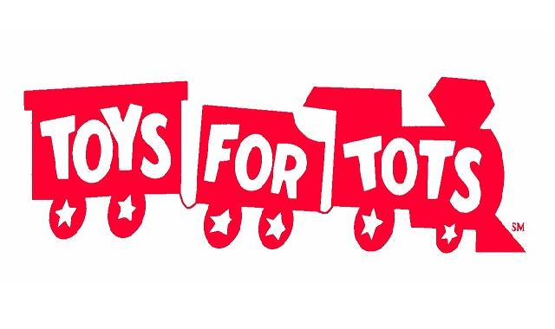
Collection Drive

November 1st - December 13th, 2023

Borough Hall

Donate a new, unwrapped toy for a child this Holiday Season.
Recommended Donations: Books, educational toys, infant toys, sports equipment, MP3 players,
watches, rolled blankets, blow dryers, etc.
(There is usually a shortage of items for children between infancy to age 3 and ages 10 & older.)

