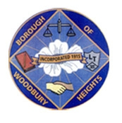 ANNOUNCEMENT!!!!!!! 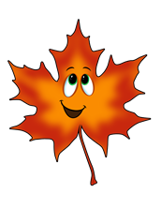
BOROUGH OF WOODBURY HEIGHTS FALL 2023 LEAF COLLECTION
CONTINUED SCHEDULE FOR COLLECTION
- Week of November 20, 2023 East Side of Railroad Tracks (Academy and Lake Sections)
- Week of November 27, 2023 finish East, West Side of Railroad Track (Tracks to RT 45)
- Week of December 4, 2023 East Side of Railroad Tracks (Academy and Lake Sections)
- Week of December 11, 2023 West Side of Railroad Track (Tracks to RT 45)
- Week of December 18, 2023 East Side of Railroad Tracks (Academy and Lake Sections)

FINAL PICKUP TO BE ANNOUNCED AFTER UPDATED SCHEDULE. PLEASE NOTE HOLIDAYS MAY DELAY PICKUP.

The department will be working endlessly to keep up with the leaves, we ask that all residents remain patient as delays WILL occur. As always, please contact Public Works with concerns or questions.

Ryan Wells
Public Works Director, Woodbury Heights
856-848-2832 ext 35
ppwm@bwhnj.com

