ATTENTION WOODBURY HEIGHTS RESIDENTS

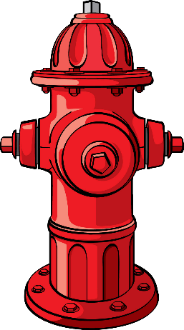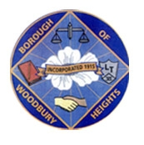

Woodbury Heights will begin its Fall Flushing program on Monday, October 16, 2023. Flushing will take place between the hours of 9:00 p.m. and 2 a.m. Residents may experience a temporary discoloration of water while flushing is in progress and shortly after. Please refrain from using water for drinking or washing clothes until the discoloration disappears. We apologize for any inconvenience this may cause. Flushing programs are important to keep the quality of the water at its best on a yearly basis.

Ryan Wells
Principal Public Works Manager/Licensed Operator

