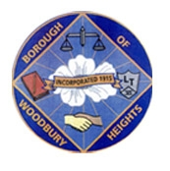 ANNOUNCEMENT!!!!!!! 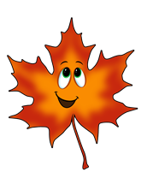
BOROUGH OF WOODBURY HEIGHTS FALL 2022 LEAF COLLECTION
FINAL PICKUP NOTICE BEGINNING DECEMBER 28, 2022

- The Public Works Department will begin their final leaf collection pickup Wednesday, December 28, 2022. We will begin in the South Wood section of town and continue through the west side of the railroad tracks (Maple/Poplar area, West Jersey area, Elm to Beech, Summit) until all streets are ran one more time. We will then head over to the east side of town (Academy, Lake, TYCO) and collect leaves one more time.

- Once leaves are collected from your house after 12/28/2022, there will NOT be another collection. Please be aware of the final pickup and place any extra leaves in cans/bags as the department clears the roads for the winter.

Ryan Wells
Public Works Director, Woodbury Heights
856-848-2832 ext 35
ppwm@bwhnj.com

