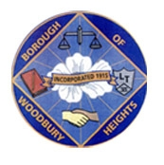 ANNOUNCEMENT!!!!!!! 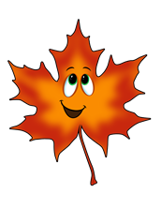
BOROUGH OF WOODBURY HEIGHTS SPRING 2022 LEAF COLLECTION
BEGINNING MONDAY, APRIL 4, 2022

THE PUBLIC WORKS DEPARTMENT WILL COLLECT CURBSIDE LEAF PILES THROUGHOUT TOWN FOR SPRING OF 2022, BEGINNING MONDAY, APRIL 4, 2022. THE DEPARTMENT WILL MAKE ONE COMPLETE PASS OF THE ENTIRE TOWN. ONCE THE LEAFER TRUCK HAS PASSED YOUR HOUSE ANY ADDITIONAL DEBRIS CAN BE COLLECTED IN CANS/BAGS FOR MONDAY’S WEEKLY BRUSH PICKUP. ANY QUESTIONS ABOUT SPRING LEAF PICKUP PLEASE CONTACT PUBLIC WORKS AT THE BELOW CONTACT INFORMATION.

RYAN WELLS
PUBLIC WORKS DIRECTOR WOODBURY HEIGHTS
PPWM@BWHNJ.COM
856-848-2832 EXT 35.

