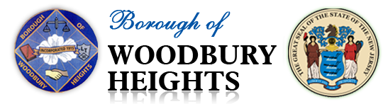
TOWN WIDE TRASH CAN DISPOSAL

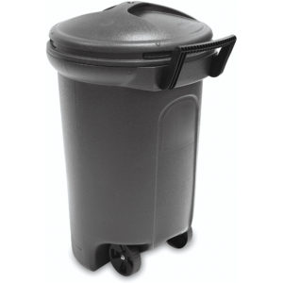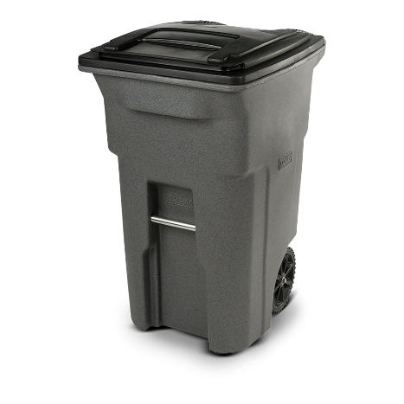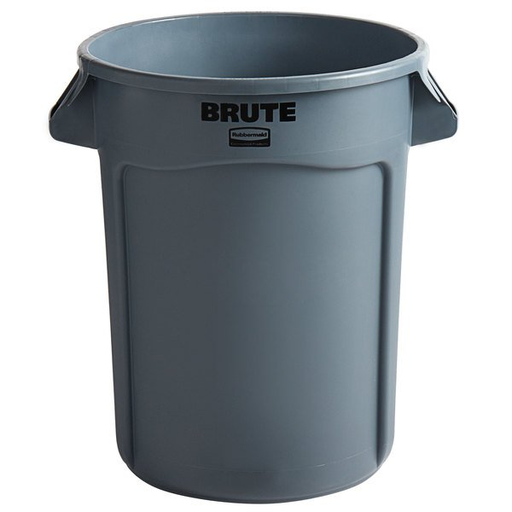

The Public Works Department will be disposing of resident’s old trash cans. Cans must be empty, turned upside down, and at the curb for collection. The following dates for collection are as follows:
- Friday, February 11^{th,} 2022
- Friday, March 11^{th,} 2022
- Friday, April 8^{th,} 2022

- Any questions or concerns please contact Public Works at 856-848-2832 ext 35 or by email at ppwm@bwhnj.com

