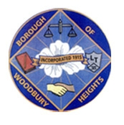 ANNOUNCEMENT!!!!!!! 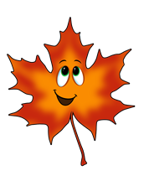
BOROUGH OF WOODBURY HEIGHTS FALL 2021 LEAF COLLECTION
Continued Schedule REVISED

- Week of December 15, 2021 East Side of Railroad Tracks (Academy and Lake Sections)
- Week of December 22, 2021 East Side of Railroad Tracks (Academy and Lake Sections)
- Week of December 29, 2021 Finish East Side of railroad tracks (if necessary), begin final pickup beginning with West Side of Railroad Tracks (Tracks to RT 45).

A FINAL PICKUP OF THE TOWN WILL BE ANNOUNCED IN THE COMING WEEKS. WE WILL COLLECT EACH STREET ONE MORE TIME.

***** Leaves that are placed in cans or bags will be collected weekly on Monday’s bi weekly yard waste collection. *****

Ryan Wells
Public Works Director, Woodbury Heights
856-848-2832 ext 35
ppwm@bwhnj.com

