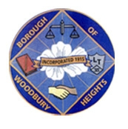 ANNOUNCEMENT!!!!!!! 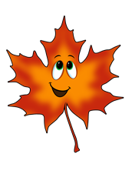
BOROUGH OF WOODBURY HEIGHTS FALL 2021 LEAF COLLECTION
Continued Schedule

- Week of November 29, 2021 East Side of Railroad Tracks (Academy and Lake Sections)
- Week of December 6, 2021 West Side of Railroad Track (Tracks to RT 45)
- Week of December 13, 2021 East Side of Railroad Tracks (Academy and Lake Sections)
- Week of December 20, 2021 West Side of Railroad Track (Tracks to RT 45)
- Week of December 27, 2021 East Side of Railroad Tracks (Academy and Lake Sections)
A final pickup will be announced in several weeks after the department is able to collect majority of the leaves curbside. We are working on a daily basis for collection.

***** Leaves that are placed in cans or bags will be collected weekly on Monday’s weekly yard waste collection. *****

Ryan Wells
Public Works Director, Woodbury Heights
856-848-2832 ext 35
ppwm@bwhnj.com

