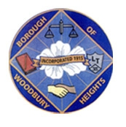 ANNOUNCEMENT!!!!!!! 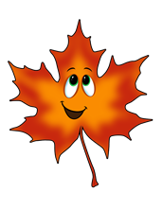
BOROUGH OF WOODBURY HEIGHTS FALL 2021 LEAF COLLECTION
IT’S THAT TIME AGAIN!

- Week of October 25, 2021 East Side of Railroad Tracks (Academy and Lake Sections)
- Week of November 1, 2021 West Side of Railroad Track (Tracks to RT 45)
- Week of November 8, 2021 East Side of Railroad Tracks (Academy and Lake Sections)
- Week of November 15, 2021 West Side of Railroad Track (Tracks to RT 45)
- Week of November 22, 2021 East Side of Railroad Tracks (Academy and Lake Sections)
*Continued schedule to follow, routes may get delayed upon quantity of pickup*

The department will be working endlessly to keep up with the leaves, we ask that all residents remain patient as delays WILL occur. As always, please contact Public Works with concerns or questions.

***** Leaves that are placed in cans or bags will be collected weekly on Monday’s weekly yard waste collection. *****

Ryan Wells
Public Works Director, Woodbury Heights
856-848-2832 ext 35
ppwm@bwhnj.com

